Benefits of Nature with Stress By. Misty Bentley

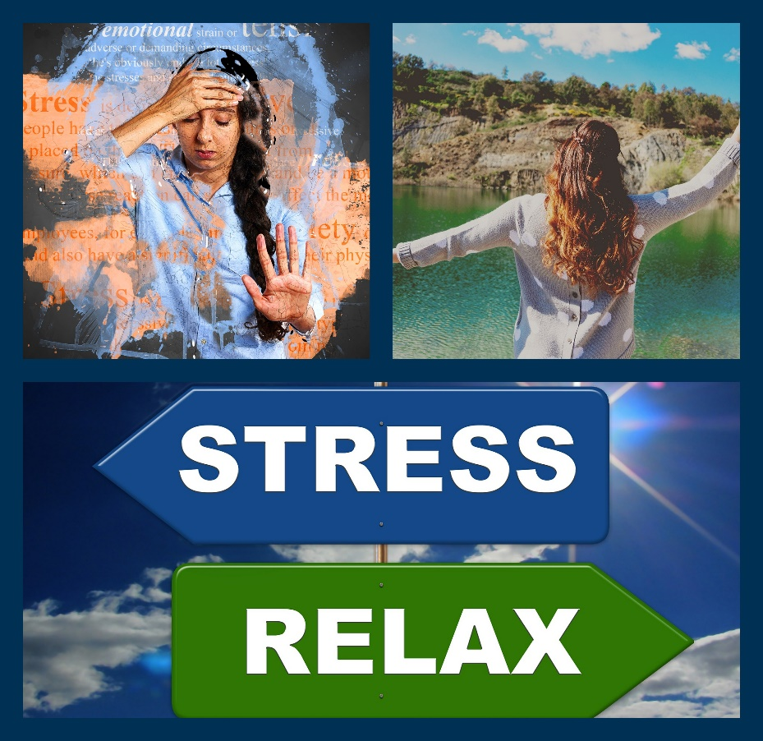
“Our perception of stress, our mental state, our immunity, our happiness and our resiliency are all chemically influenced by the nervous system and its response to natural environment” (2).

We tend to ignore the reality of what stress can do to us, with how we function, mentally and physically. Stress actually throws our entire body out of whack, making our organs function abnormally and hormones can become imbalanced which can lead to cognitive disruption, as well as physical difficulties.

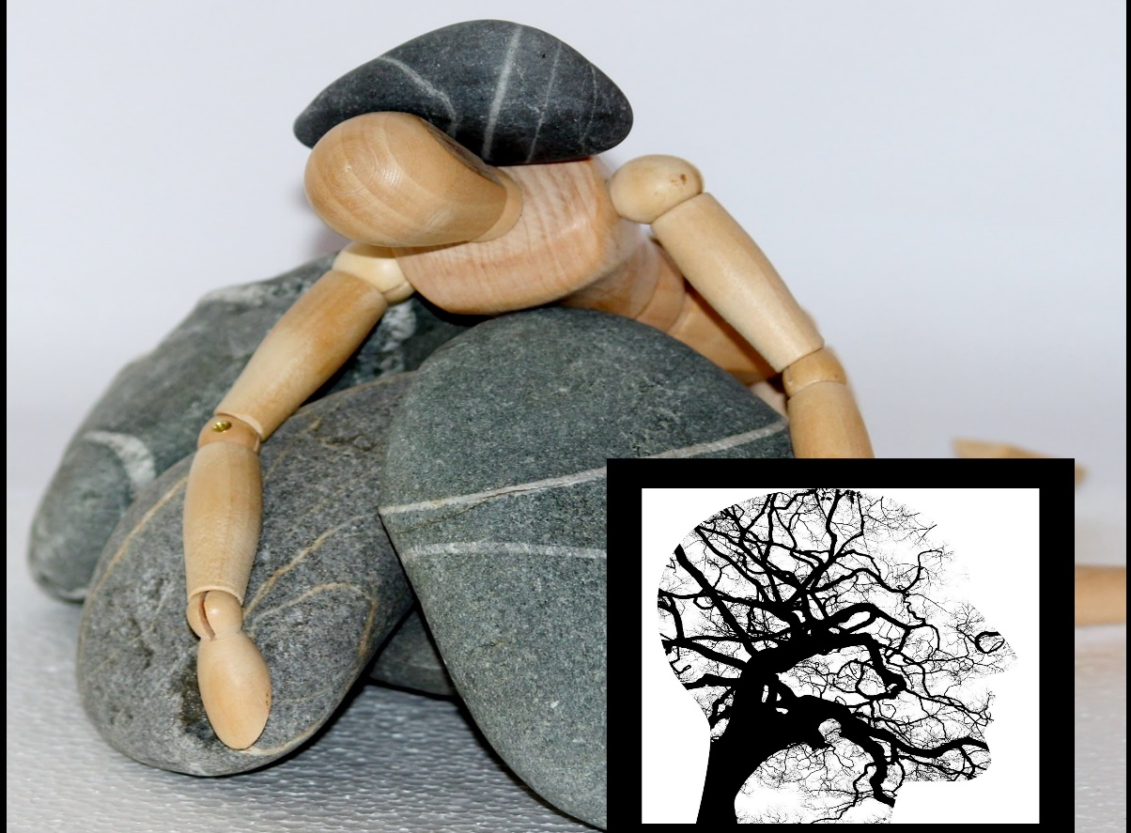

The things we stress about are not what our bodies were created to react to. We are at a constant arousal state from having deadlines, dinner to cook, practice to make, or family issues and financial struggles. We are worrying about our images and who has more than the other or focusing on having this lifestyle of being technology dependent to “make life easier” when in fact it is causing more stress.

Just take a moment and think about how you feel after being outside doing something and taking in the fresh air and natural beauty. It is supported by the National Institute of health, that natural environments, plants or even pictures and visions of nature can decrease anxiety and stress (3). Studies were done with hospital patients to see if there was a difference in behavior in an urban setting compared to a more nature scenic setting. It was noticed that patients tended to be calmer and more relaxed and shown less fear when they had a view of some sort of nature. (2)

Some examples of nature that could be useful, favorite flowers, fresh cut grass, the smell of the leaves, the sight of a waterfall, walking through a big green mountain standing tall and strong or even the sounds of the wind through the trees. All of which could assist in clearing your mind and elevate some stress and anxious feelings.
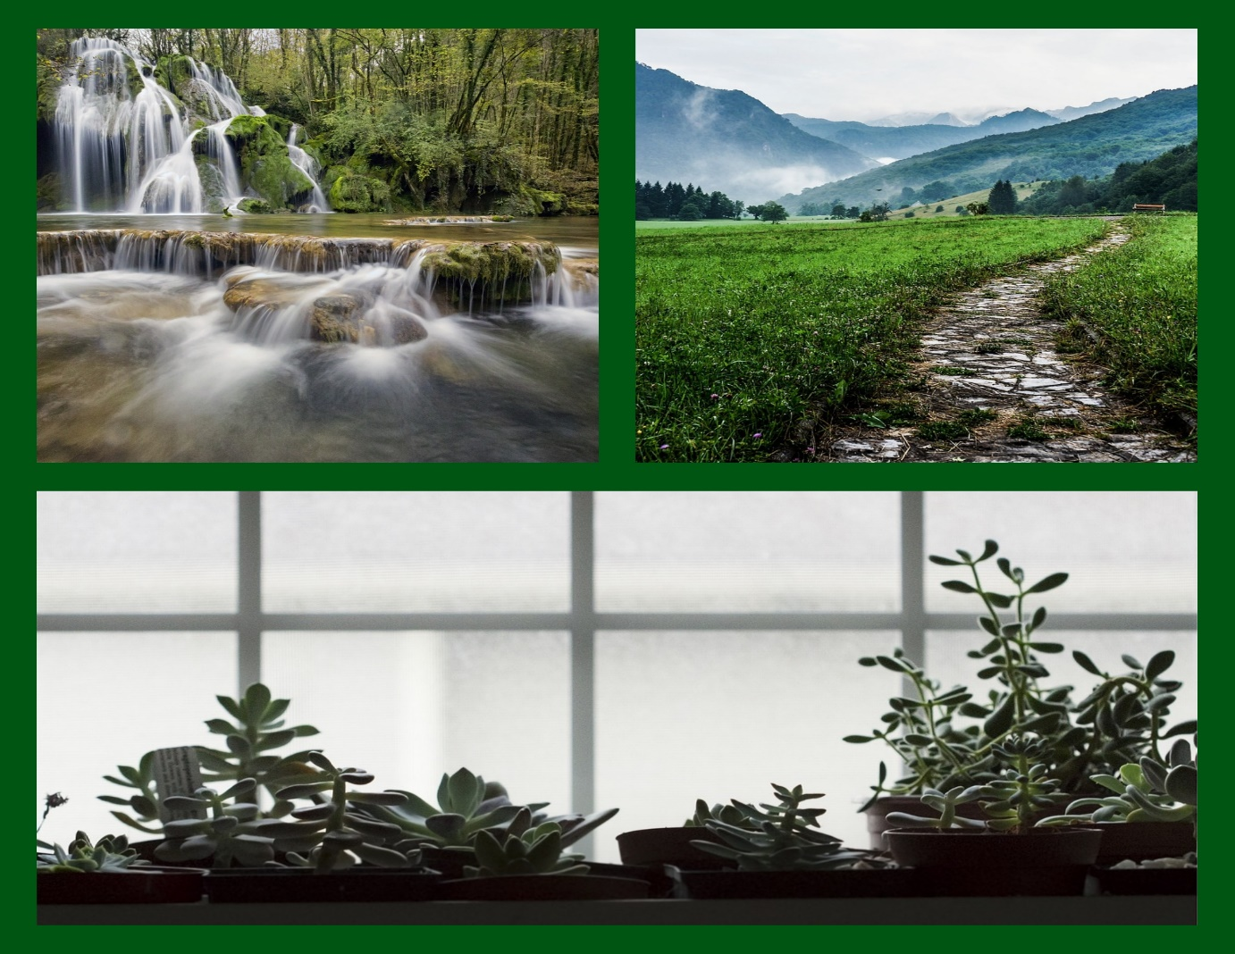

Research found that the average person spends up to 95 % of their day indoors (2). None of us really think about it or the importance, but we are sitting in rooms with no fresh air all day, we need that fresh natural air. Stress can sometimes cause an overload or state of mental exhaustion that we can have a hard time communicating and just functioning, yet nature can decrease the unwanted side effects of stress. It was supported in The Essentials of managing Stress, that connecting with nature can give a variety of good benefits like our mental well-being, cognitive skills and physical health, whether it be photos, sounds, plants or the great outdoors. (2) It was written in Landscaping and urban planning that nature can decrease anxiety as well as improve work memory skills, and that greenspace can improve cognition (4). Steven Kellert stated that “we have an inherent connection and affinity to the natural world” (2), so go ahead and give it a try.

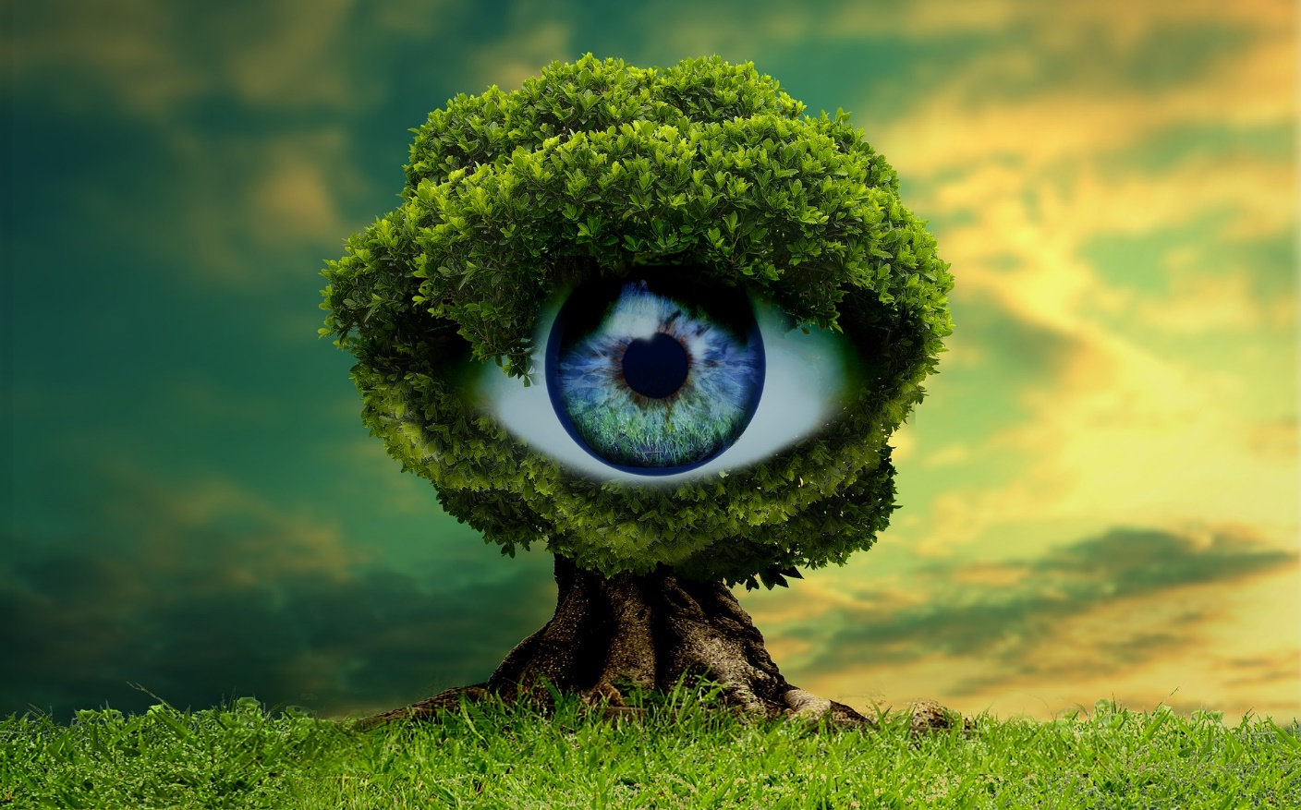
Next time you feel stressed out or overwhelmed, surround yourself with some kind of natural atmosphere and be mindful of it. Make sure to notice the beauty and the calmness it has to offer you and notice the shift in your feelings and emotions.
You be the judge, but I don’t think you will be disappointed.

- 5 Things You Should Know About Stress. (n.d.). Retrieved March 4, 2019, from https://www.nimh.nih.gov/health/publications/stress/index.shtml

- Seaward, B. L. (2017). Essentials of managing stress. Burlington, MA: Jones & Bartlett Learning.
Chapter 24.
- What are the Benefits of Interacting with Nature? (n.d.). Retrieved March 4, 2019, from https://www.ncbi.nlm.nih.gov/pmc/articles/PMC3709294/
- The benefits of nature experience: Improved affect and cognition. (n.d.). Retrieved from Landscape and urban planning
https://www.sciencedirect.com/science/article

