Checklist for Building a New Moodle Course for Web-Enhanced courses
For resources, instructions and information, visit BCC Online Learning

If you would like to start using Moodle at BCC, your first step is to either attend an “Introduction to Moodle” workshop or schedule a one-hour orientation to Moodle with Online Learning staff. Once you have mastered the basics, proceed to use this checklist to add your materials in Moodle.

Please use this checklist as a reminder/guide for your Moodle work after you have taken an instructor orientation or an Introduction to Moodle workshop. Moodle course spaces are automatically created by the BCC student registration system. Your Moodle course will have all of your students present in it, and the course will automatically reflect adds and withdrawals throughout the semester.

If you are using your Moodle course space for the first time, be sure that you have attended an Introduction to Moodle workshop and/or met with Janet Collins for a one-hour orientation to Moodle.

When you are ready to work on your course, log in to MyBCC. In the center panel, you will see a list of your Moodle courses. Click the course you wish to work on.

Go to Administration > My profile settings > Edit profile, and be sure to update your profile information if needed. Remember, your Moodle profile is viewable across all of your Moodle courses, so keep it general and generic. Only include contact information that you want all students to see. Please do include a photo.

Go to Administration > Edit settings to review the Theme, set the number of Sections, choose Weekly, Topic or Collapsed Topic format, etc. Your Moodle course is automatically set at 16 Topics when you first open it. Note: the Mobile theme is automatically set to appear when your Moodle course is accessed by a mobile device.

Incorporate best practices for online course design:
- Make sure to have a “Getting Started” section that explains to students how you are using Moodle and what your expectations are, even if you are teaching an on-campus class. You can suggest or require that students take the self-led Student Moodle Orientation in order to get familiar with Moodle. A link to the Student Moodle Orientation is on the Online Learning site.
- Design by “chunking” content. Think of a single unit, lesson, or “chunk” as incorporating learning objectives, course Resources (readings, web links, videos, etc.), interactive Activities (forums, polls, etc.), and assessments. This is good practice even for an on-campus course – and you will be ahead if you decide to teach online down the road.
- Videos or lectures online should be no longer than 20 minutes, 10 is better.
- Over-communicate deadlines (use course announcements, labels, alerts, and email reminders)
- Balance text with some visual components
- Be present and create presence in the online course. If you are there, your students will be there. Don’t make it a dead space.

If you are using the Topics format, to make your course more useable for students, click the “wheel” icon at the top-left of each Section and provide a custom Section name. The name can either be a range of dates for that section, or the topic of that course unit.
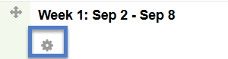

To add content or “Resources” to your course, click Turn editing on (top right) of your course page.

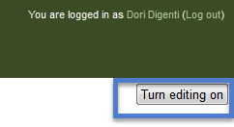

To add files, labels, pages, and links, Turn editing on. At the bottom of the Section where you want the Resource to appear, click + Add an activity or resource. Select the type of resource or activity (you may need to scroll down the list to see all resources) and click Add, then configure the resource/activity and click Save (at bottom of screen). Then move your resource into the position you would like clicking and dragging the cross icon.
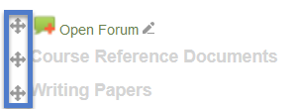

If you wish to edit a Resource or Activity in Moodle after you have created it, Turn editing on. You will see small icons will appear vertically under the “Edit” link on the right of the course page. Select the appropriate edit action from the icons.

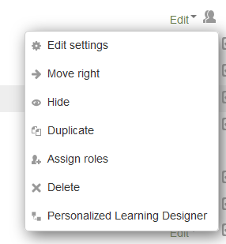

Most faculty will benefit from separate workshop instruction to use the Activities in Moodle. To add interactive tools such as Forums, Assignments, Quizzes, etc., turn editing on. In the Section where you want the Activity to appear, click + Add an activity or resource to open the Activity chooser. Select an activity and click Add, then configure the settings and click Save (at bottom of screen). Note: Attendance, Quizzes, Glossaries, and Databases require additional setup from within the activity. Open the activity to complete the set up.

Blocks are single-purpose navigation areas on the right or left of your course page. The standard Blocks that come with your Moodle course include: Navigation, Administration, Calendar, Quickmail, and Help. To change which blocks appear in your course and where they appear, click Turn editing on: To add a new block, use the Add a block… drop-down at the bottom of the right column. To delete a Block, click the X icon in the block heading.

Moodle courses are hidden from students until the instructor unhides them. Turn editing on, and in the Administration block, click Edit Settings, and then under Visible select “Show.” Scroll down to Save.

