Setting Up Folders in Outlook for Quickmail

Step 1: Create a folder in Outlook for your course emails.
- Under the tab "Folder," click the button for "New Folder".

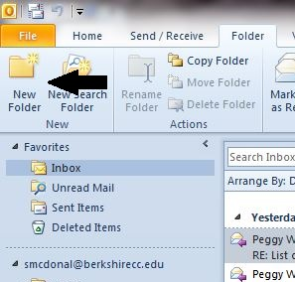

- When the "Create New Folder" window appears, enter the name you wish to give the folder (use the Course name, e.g. BUS-107-01) and click "OK." (Note: The choice under the "Folder contains" drop-down menu should be "Mail and Post Items".

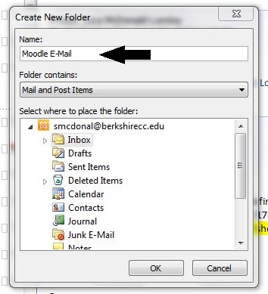

- The new folder should show up in the list of folders under your Inbox. If you don't see it, click the white arrow beside the inbox and display all folders. (If the arrow beside your Inbox folder is black, all folders are already expanded.)

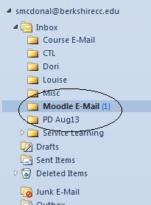

"Step 2: Create a "Rule" in Outlook to send course emails to that folder.
- Under the "Home" tab, select "Rules" and then "Create Rule…" from the drop-down menu.
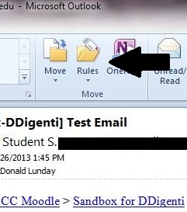

- Check the box labeled "Subject contains". In the space beside it, type in the name of the course, as provided by Moodle. (This will be in [Brackets].)
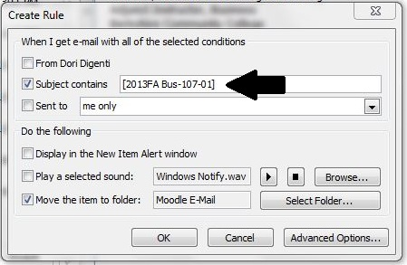
- Check the box labeled "Move the item to folder:".
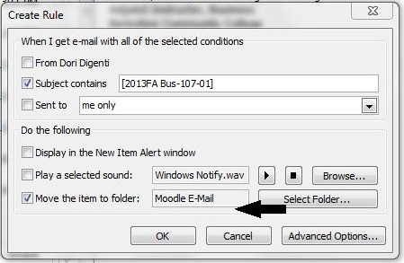

Click on the button "Select Folder…" and chose the folder you created in Step 1. Click "OK".
Click "OK" for Create Rule window. Click "OK" for Success window.
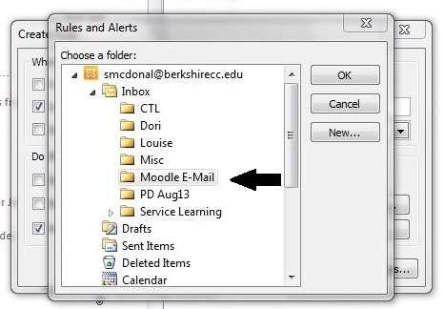
All emails containing the prepended course name from Moodle in the subject line should now go directly into the folder, making it easier for you to keep track of your course emails.

To view emails in "Conversation" form:
- Select the "View" tab when looking in the folder for your course emails.

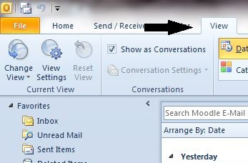

- Check the box "Show as Conversations".

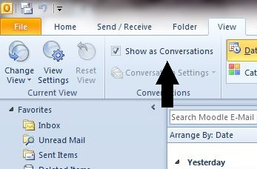

- A window will pop up asking if you want to see all emails as conversations, or only that folder. Select "This folder".

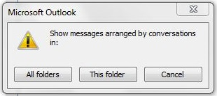

- The conversation view will look like this:

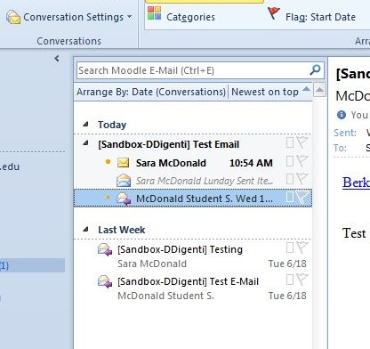

Important:
When you use Quickmail, instruct your students to reply without changing the Subject line. In order for the rule to keep all your emails together in your Outlook folder, the Subject line must contain "[Semester Course-Number-Section]",
e.g. [2013FA BUS-107-01].

