Look at the list of numbers. Circle or highlight the numbers that have spellings it seems to you that you’ll have to pay attention to. Notice which numbers are ONE word and those that are THREE words. Notice irregularities like tildes (accent marks) and when E precedes I.
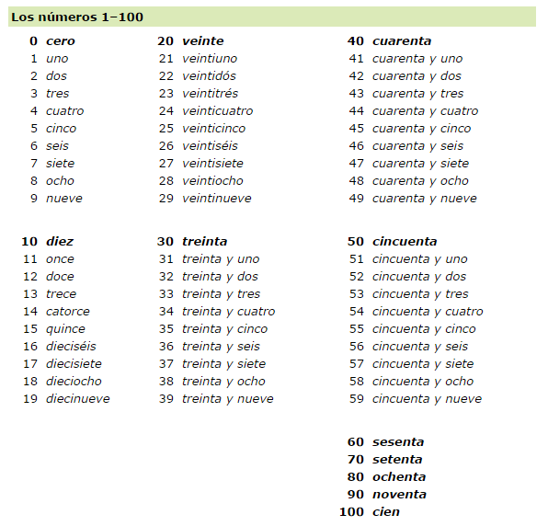
1. Los códigos postales: You and your classmates are discussing where you are from. Write
out the following zip codes using numbers.

MODELO: 98781 nueve-ocho-siete-ocho-uno
1. 48295 __________________ 3. 48718 __________________
2. 12785 __________________ 4. 65716 __________________
Ejercicio P.4 Los números de teléfono: Now, you and your classmates would like to share phone
numbers. Write out the phone numbers.

MODELO: 895-7489 ocho-noventa y cinco-setenta y cuatro-ochenta y nueve
1. 641-5519 ______________________________________________
2. 323-6233 ______________________________________________
3. 481-0931 ______________________________________________
4. 539-5743 ______________________________________________

